Teenage Experience in the 1930s
Samantha Garlock, Sammy Gibbons, Kate Fletcher, Kayla Goetz

Theme: Teenage girls in the 1930s are not much different from those of today. They passed notes to gossip with their friends, kept up with the latest fashions, and began to grow out of playing with their dolls, which influenced their lives more than they may realize.
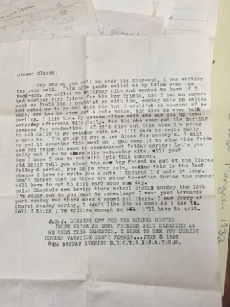
Notes Between Teenage Girls in 1932:
- Letter between two school-aged friends in 1932
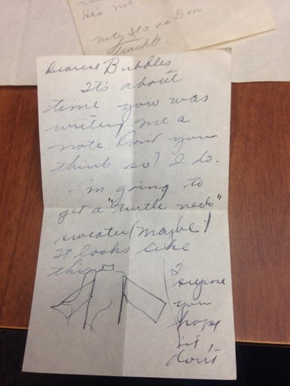
- Colloquial and candid writing; insight into teen girl everyday experiences and what they consider important
Keywords: girlhood, gender, and domestic
- Emphasis on social engagements and romantic relationships

- Short-sleeve turtleneck sweaters were becoming fashionable among “college girls.” Margie may have been drawn to the style because she perceived it as mature.
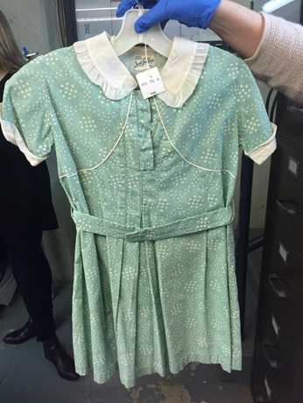
- Margie and Gladys would have received penmanship instruction at school, most likely in the Palmer method (a form of cursive that basically looks a lot like the cursive that was taught in schools through the 1990s).

1930s Dress:
- Usually above the knee, made of cotton, with a peter pan collar
- Worn with black Mary Jane shoes and knee or ankle socks
- Evolving hemline
- Relates to the keyword “gender” and “girlhood”
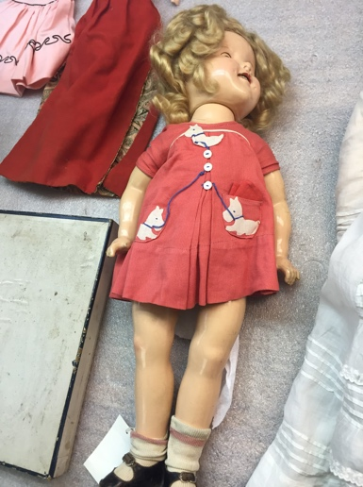
Influence of Dolls on Girls in the 1930s:
- Shirley Temple doll made around 1934, made to look like film star
- Dolls set “norms” for girls, girls are meant to take care of it and sets physical appearance standard (short dress, high socks, short hair)
- Scripted play for young women
- Popular culture link

