ARCHIVAL RESEARCH PROJECT
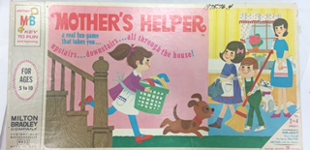
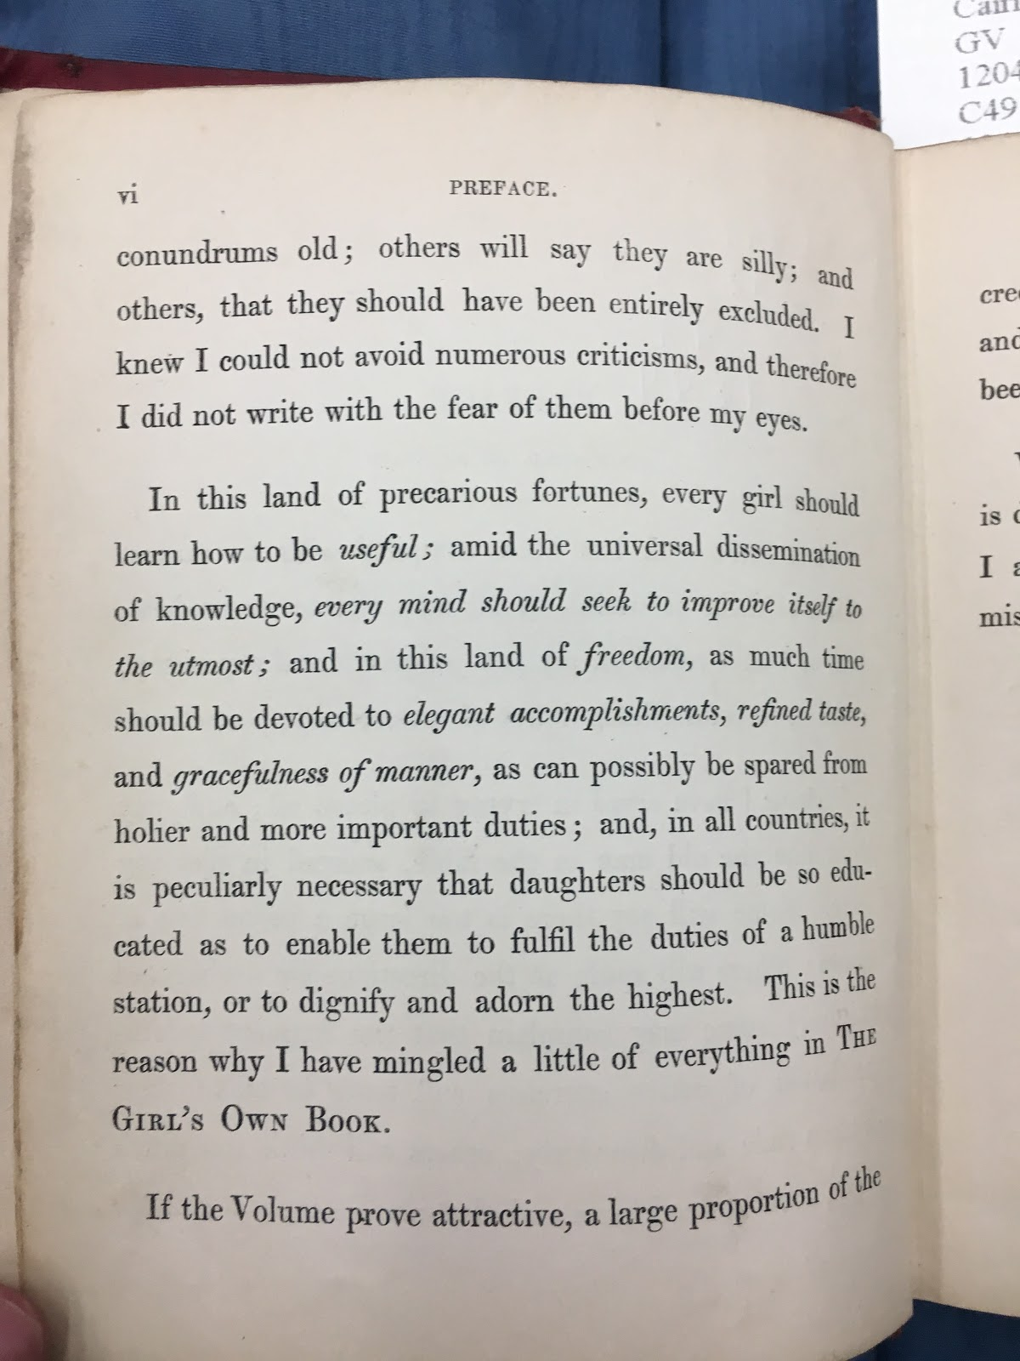
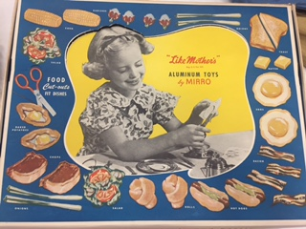
By: Alison Bacon, Abbie Bogli, Alicia Bohne & Madison Dietzel

- Derives from Lydia Maria Child’s book “The Girl’s Own Book.” Published in Boston in 1833.

- Young girls learned domesticity and how to act ladylike through the use of games, rhymes and songs.
- The passage showcases girlhood (gender performativity) and domesticity during the Victorian Era.
- Child’s uses statements such as “Gracefulness of manner” and “Elegant accomplishments.”
- Significant difference between how girls were taught to play in the 19th century compared to present day. → Changed with girls’ roles in society.

- “Little Mother’s” is an aluminum dinner toy set that was created between 1949 and 1953 by Aluminum Goods Manufacturing Company out of Manitowoc, Wisconsin.
- -This particular item is a part of the WHS museum collections.
- It was said to have been purchased on eBay November 23, 2005 from a seller in Watkinsville, Georgia.
- It consists of many detailed pieces such as dinner plates, cups, silverware, napkins, and even a lazy susan.
- It is said that girls' toys at this time were made to help prepare
young girls for their future role as a woman and wife.

- Created by Milton Bradley Company out of Springfield Massachusetts
- This game involves having the children race throughout the house to see who can complete the chores quickest
- Game consists of game board, spinner, instructions, four game pieces, and twenty playing cards & can be played by 2-4 players
- Many mid-nineteenth century games were created to teach good behavior and morals
- Item is held in the Wisconsin Historical Society Museum and the date it was obtained is unknown

CONNECTIONS TO CLASS
- “Little Mother’s”- Little Women; domestic duties and gender roles.
- “Mother’s Helper”- Little Women & Little House on the Prairie; domestic chores and family life.
- “The Girl’s Own Book”- Little Women & Little House on the Prairie; roles of young girls.

