Archival Research Assignment

* American Girl’s Homebook, p.276
* Hellen Campbell, 1883
* Various activities and rules for girls
  + Doll houses, make-believe housekeeping, dress making, sewing.
* Domesticity and play emphasized in girlhood
* Relation to the keywords essay
  + Ideas about domesticity
* Writing style
  + Primp and proper tone
  + Reflects values of properness and domesticity was in girlhood during this time
* About the author
  + Hellen Campbell
  + Seems to place a high emphasis on appearance and behavior of young girls
  + Views girlhood as a timeframe to mold young girls into respectable and proper young women
  + Values a domestic girlhood by encouraging domestic play and respectable behavior
* Historical Context
  + Written in 1883, commonly read by young girls
  + Used to give young girls ideas of past time activities
* Our Study of American Girls and Girlhood
  + Demonstrates our discussions about domesticity and play
  + Shows how play during girlhood has changed over the years.

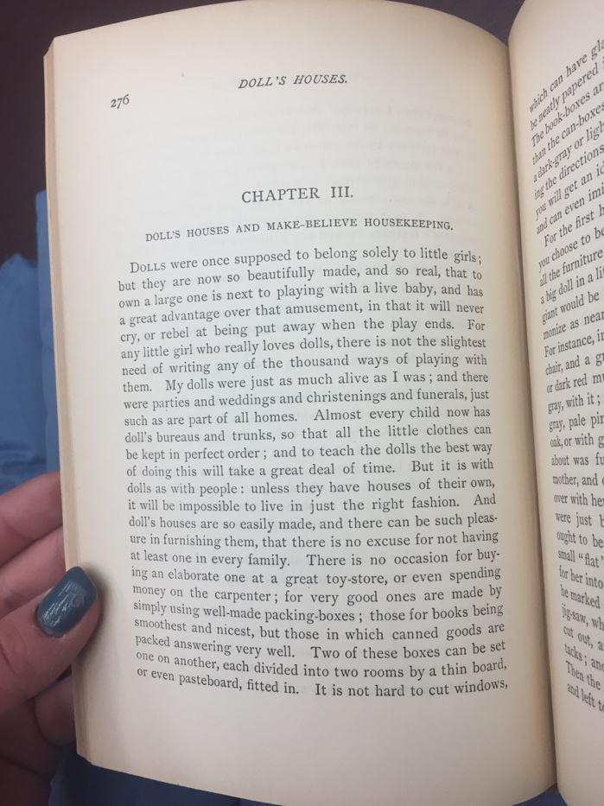

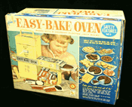

* Easy-bake Oven, 1964
* Cincinnati, Ohio
* Which collection? How was it obtained?
  + Wisconsin Historical Society
  + Donated by Marie Larsen
    - Purchased for grandson
    - Generally seen as girl toy
* What to Know About the Product:
  + Targeted to young girls
  + Set includes baking tools
* Significance to our study of American Girls/Girlhood
  + Demonstrates marketing to female community of domesticity
  + Stereotypical gender norms for play
  + Representation of domestic scripted play in girlhood

Kenner’s Easy-Bake Oven with accessories, Cincinnati, Ohio, 1964

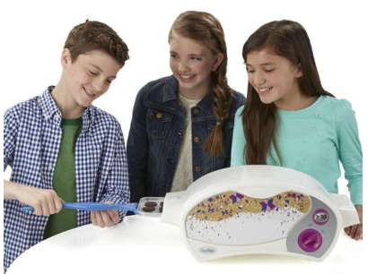

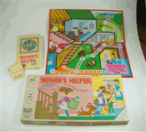

* Mother’s Helper board game, 1968
* Milton Bradley Company, Springfield, Massachusetts
* What to Know About the Product:
  + Combines competition and learning domestic duties
  + Complete chores to be the winning Mother’s Helper
  + Targeted to young girls
* Which collection? How was it obtained?
  + Wisconsin Historical Society
  + Donated by anonymous client
* Significance to our study of American Girls/Girlhood
  + Enforces the idea of domesticity
  + Popular children’s toy that teaches idea of domesticity
  + Attraction to domestic roles for young girls

1968, “Mother’s Helper” board game and accessories, Milton Bradley Company, Springfield, Massachusetts