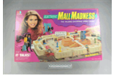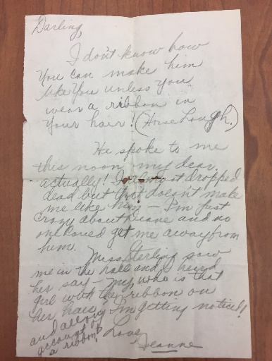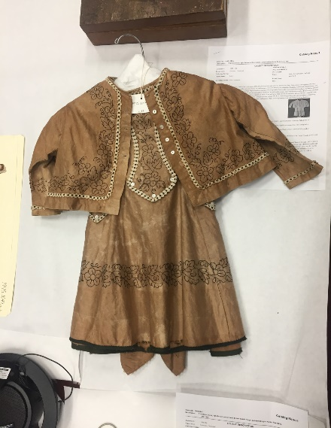

**Gladys and Jeanne Letters-1932:**

* **“I don’t know how you can make him like you unless you wear a ribbon in your hair! (Horse laugh).”**
* Jeanne and her friends (Gladys) passed notes about boys, classes, grades, weekend plans, and their physical attributes
* These letters showcase girlhood in the 20th Century
* Gender performativity in childhood is displayed through their participation in girl culture (via clothing and gossip)
* Jeanne and Gladys wrote about physical attributes (their hair) and shows how attire can be tied to a specific gander
* This piece correlates with texting in today’s society and gossip remains

**All items:**

* were obtained via the Wisconsin Historical Society Museum Collection
* involve gender stereotypes and gender performative qualities
* can be related to today’s society and how such stereotypes have been reinforced and modified

**Mall Madness-1988:**

* Mall Madness is a board game that is targeted towards girls through its scripting values and gender stereotypes
* This specific targeting is done through advertising and marketing (color choice and image choice)
* Mall Madness was released by Milton Bradley in 1988 but new versions continue to be made
* The colors used in the game coincide with ideas of girlhood and gender, perpetuating stereotypes
* The girls pictured on the cover script a play target to girls only

**Boys Dress- 1850’s:**

* Handmade dress for a boy
* Was worn in 1871
* Louis War Claude is the boy

who wore the dress.

* He lived in Baraboo, WI and

Passed away in Madison

* Hand Woven by his great

aunt Miss Louise Claude

* + Embroidery and

pearls (seen in both

black and white thread)

* Typical of the time for boys to wear dresses
* Likely obtained by family as they reside near Madison
* Outfit goes against gender norms seen today
* Gender stereotypes are enforced through a social education of gender and its tie to apparel

**Archival Research Project**

**Kaitlin Maxa, Allie Lawrence, Alexis Mauermann, & Brit Karnowski**